**ROTRAY CLUB OF BIRATNAGAR DOWNTOWN**

**SHRAWAN MELA 2017**

**Community Service**

1. **Trade Fair:**

* **Rotary club of downtown organized a mega event – SHRAWAN MELA, a 2 days Trade Fair 21st and 22nd July, 2017, at Atithi Sadan, Biratnagar to promote women Entrepreneurship.**
* **35 stalls which exhibit cloth jewellery, bed cover, rakhis, footwear, handicrafts, game, food, etc. attracted more than 2500 people from all communities.**
* **More than 100 women entrepreneur who need a platform to promote the cottage business were benefited.**
* **Honourable Mrs. Indrira Karki, Vice Mayor of Biratnagar graced the occasion as Chief Guest and our Esteem Assistant Governor Rtn. Sushil Rijal also graced the occasion as Guest of honour.**

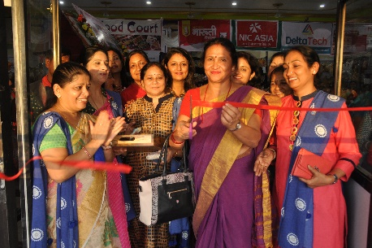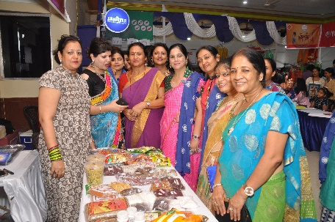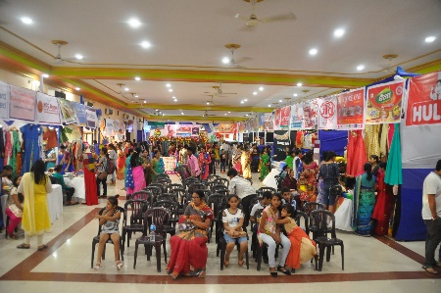

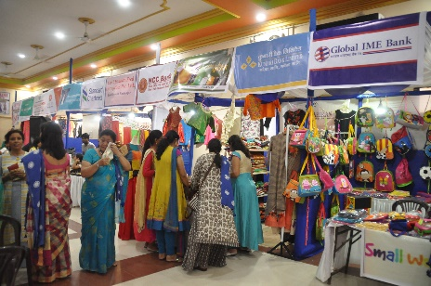 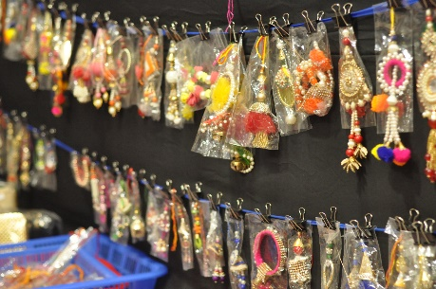 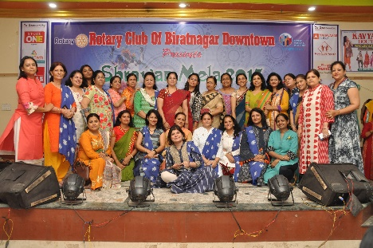

1. **Mom & Kid Show:**

* **Rotary club of Biratnagar Downtown provided the platform for married ladies specially housewives with their kids by organising a programme “Mom & Kid” show on 21st August 2017, at Atithi Sadan, to enhance their quality and to boost their confidence.**
* **8 pairs of mom and kid were participated in the programme. One of our new member Rtn. Santosh Rathi was also participated with her daughter.**
* **Ladies and kids enjoyed a lot. Kids were very happy because first time they had an opportunity to perform with their mom. Family members of participant, as well as the gathering enjoyed the programme.**

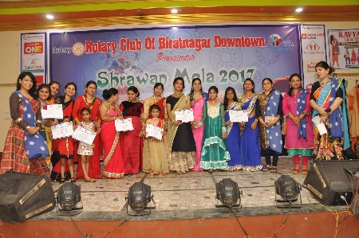 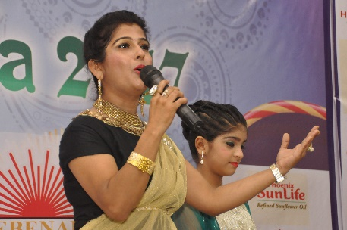 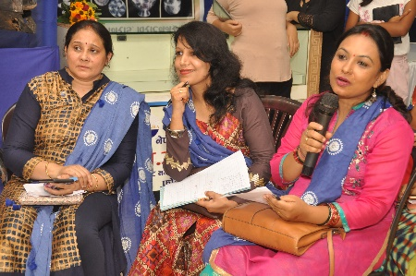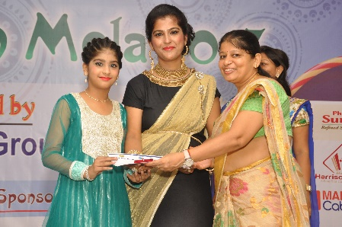 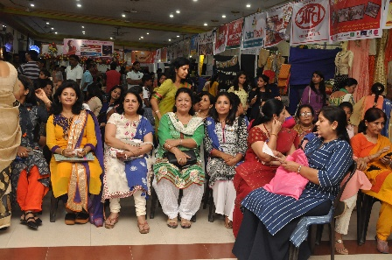 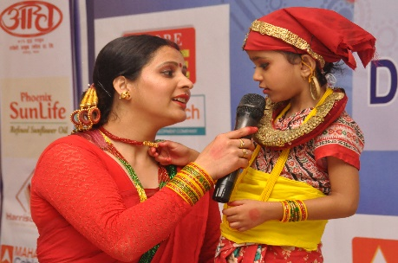

1. **C.P. Baby Play “PRAYAS”:**

* **Rotary Club of Biratnagar Downtown organized a play “PRAYAS” for C.P. children on 22nd July, 2017 at Atithi Sadan.**
* **C.P. care centre is our signature project which is run at Adarsh Vidyalaya, Biratnagar. There are 15 children who are given Physiotherapy, Speech therapy, Transportation facility and Mid-day meals.**
* **It is our dream to construct a full-fledged C.P. building for which land has been donated to us.**
* **The main aim of this play was to make people aware of this disease and to encourage them to help us by providing fund for the construction of building.**
* **Club members participated in this play and a gathering of 1500 people witnessed it.**

